Precious Pictures of Marilyn Monroe

Marilyn Monroe personified Hollywood glamour with an unparalleled glow and energy that enamored the world. Although she was an alluring beauty with voluptuous curves and a generous pout, Marilyn was more than a '50s sex goddess. Her apparent vulnerability and innocence, in combination with an innate sensuality, has endeared her to the global consciousness. She dominated the age of movie stars to become, without question, the most famous woman of the 20th Century.
She was born Norma Jeane Mortenson on June 1, 1926 in Los Angeles, California, to Gladys Baker. As the identity of her father is undetermined, she was later baptized Norma Jeane Baker. Gladys had been a film cutter at RKO studios, but psychological problems prevented her from keeping the job and she was eventually committed to a mental institution.
Norma Jeane spent most of her childhood in foster homes and orphanages until 1937, when she moved in with family friend Grace McKee Goddard. Unfortunately, when Grace's husband was transferred to the East Coast in 1942, the couple couldn't afford to take 16-year-old Norma Jeane with them. Norma Jeane had two options: return to the orphanage or get married.
On June 19, 1942 she wed her 21-year-old neighbor Jimmy Dougherty, whom she had been dating for six months. "She was a sweet, generous and religious girl," Jimmy said. "She liked to be cuddled." By all accounts Norma Jeane loved Jimmy, and they were happy together until he joined the Merchant Marines and was sent to the South Pacific in 1944.

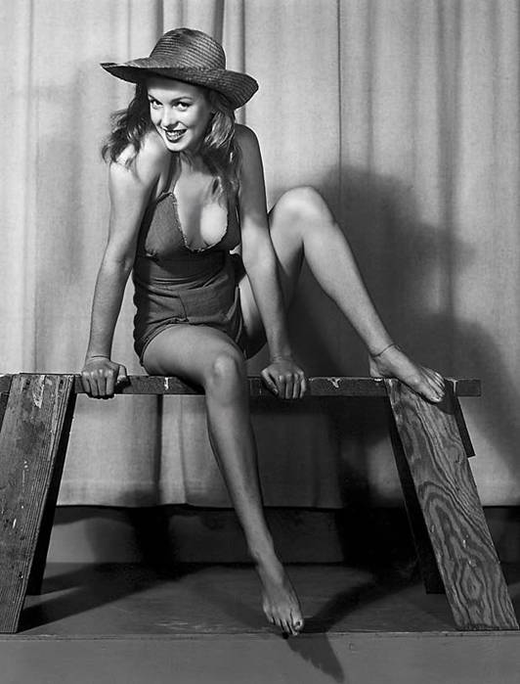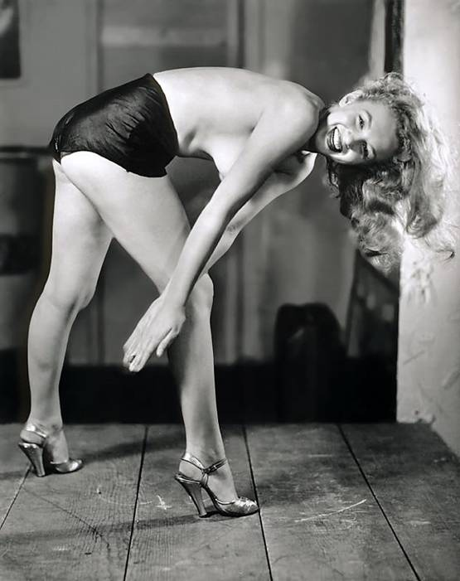
After Jimmy left, Norma Jeane took a job on the assembly line at the Radio Plane Munitions factory in Burbank, California. Several months later, photographer David Conover saw her while taking pictures of women contributing to the war effort for Yank magazine. He couldn't believe his luck. She was a "photographer's dream." Conover used her for the shoot and then began sending modeling jobs her way. The camera loved Norma Jeane, and within two years she was a reputable model with many popular magazine covers to her credit. She began studying the work of legendary actresses Jean Harlow and Lana Turner, and enrolled in drama classes with dreams of stardom. However, Jimmy's return in 1946 meant Norma Jeane had to make another choice- this time between her marriage and her career.
Norma Jeane divorced Jimmy in June of 1946, and signed her first studio contract with Twentieth Century Fox on August 26, 1946. She earned $125 a week. Soon after, Norma Jeane dyed her hair blonde and changed her name to Marilyn Monroe (borrowing her grandmother's last name). The rest, as the saying goes, is history.
Marilyn's first movie role was a bit part in 1947's The Shocking Miss Pilgrim. She played a series of inconsequential characters until 1950, when John Huston's thriller The Asphalt Jungle provided her with a small but influential role. Later that year, Marilyn's performance as Claudia Caswell in All About Eve (starring Bette Davis) earned her further praise. From then on Marilyn worked steadily in movies such as: Let's Make It Legal, As Young As You Feel, Monkey Business and Don't Bother to Knock. It was her performance in 1953's Niagara, however, that delivered her to stardom. Marilyn played Rose Loomis, a beautiful young wife who plots to kill her older, jealous husband (Joseph Cotten).
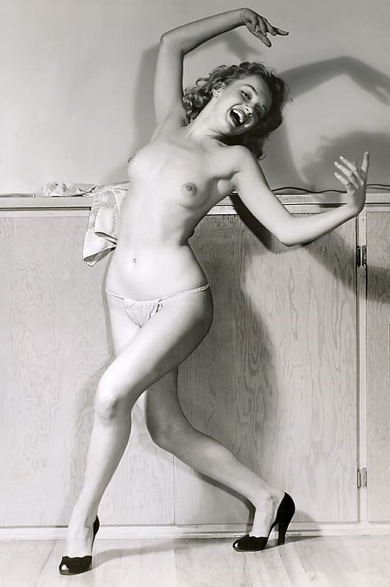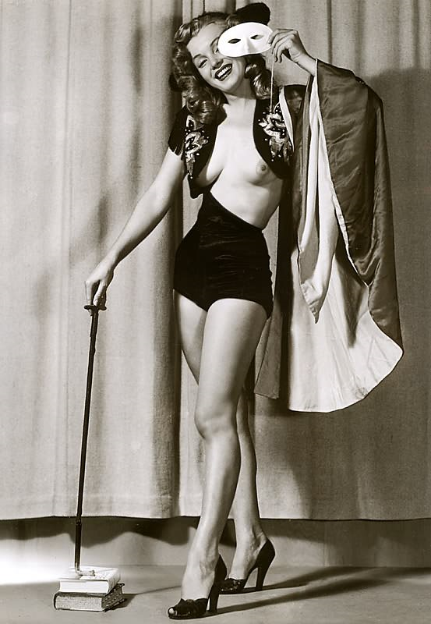
Marilyn's success in Niagara was followed with lead roles in the wildly popular Gentlemen Prefer Blondes (co-starring Jane Russell) and How to Marry a Millionaire (co-starring Lauren Bacall and Betty Grable). Photoplay magazine voted Marilyn the Best New Actress of 1953, and at 27 years old she was undeniably the best-loved blonde bombshell in Hollywood.
On January 14, 1954, Marilyn married baseball superstar Joe DiMaggio at San Francisco's City Hall. They had been a couple for two years, after Joe asked his agent to arrange a dinner date. "I don't know if I'm in love with him yet," Marilyn said when the press got word of their relationship, "but I know I like him more than any man I've ever met." During their Tokyo honeymoon, Marilyn took time to perform for the service men stationed in Korea. Her presence caused a near-riot among the troops, and Joe was clearly uncomfortable with thousands of men ogling his new bride.
Unfortunately, Marilyn's fame and sexual image became a theme that haunted their marriage. Nine months later on October 27, 1954, Marilyn and Joe divorced. They attributed the split to a "conflict of careers," and remained close friends.
Marilyn was ready to shed her "shallow blonde" image by 1955. It had gotten her into the spotlight, but now that she had the opportunity and experience, Marilyn wanted to pursue serious acting. She took a hiatus from Hollywood and moved to New York City to study under Lee Strasberg at his Actors' Studio. In 1956, Marilyn started her own motion picture company, Marilyn Monroe Productions. The company produced Bus Stop and The Prince and the Showgirl (co-starring Sir Laurence Olivier). These two films allowed her to demonstrate her talent and versatility as an actress. Marilyn received further recognition for 1959's Some Like It Hot, winning a Golden Globe for Best Actress in a Comedy.
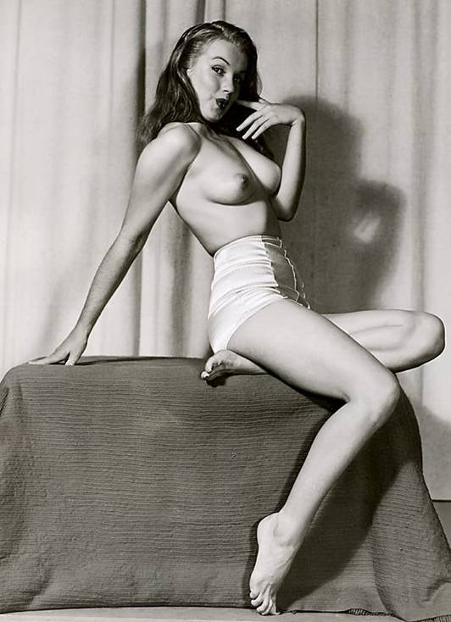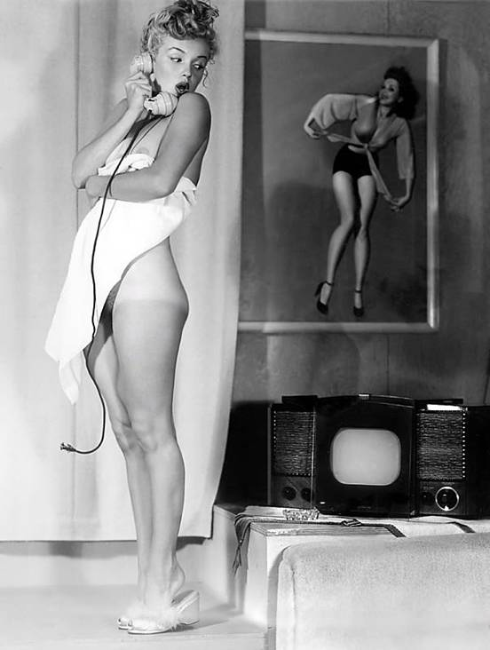
On June 29, 1956, Marilyn wed playwright Arthur Miller. The couple met through Lee Strasberg, and friends reported she made him "giddy." While they were married, Arthur wrote the part of Roslyn Taber in 1961's The Misfits especially for Marilyn. The movie co-starred Clark Gable and Montgomery Clift. Sadly, the marriage between Marilyn and Arthur ended on January 20, 1961, and The Misfits was to be Marilyn's (and Gable's) last completed film.
At the 1962 Golden Globes, Marilyn was named female World Film Favorite, once again demonstrating her widespread appeal.
Sadly, in a shocking turn of events on the early morning of August 5, 1962, 36-year-old Marilyn died in her sleep at her Brentwood, California home. The world was stunned. Marilyn's vibrant spirit and beauty made it impossible to believe she was gone. On August 8, 1962, Marilyn's body was laid to rest in the Corridor of Memories, #24, at Westwood Memorial Park in Los Angeles, California.
During her career, Marilyn made 30 films and left one, Something's Got to Give, unfinished. She was more than just a movie star or glamour queen. A global sensation in her lifetime, Marilyn's popularity has extended beyond star status to icon. Today, the name "Marilyn Monroe" is synonymous with beauty, sensuality and effervescence. She remains an inspiration to all who strive to overcome personal obstacles for the goal of achieving greatness.
